Supplemental Figures

Yuta Suzuki

4/23/2021

Supplemental Figures for “Temporal dynamics of auditory bistable perception correlated with a fluctuation of baseline pupil size”

Yuta Suzuki, Hsin-I Liao, Shigeto Furukawa

NTT Communication Science Laboratories, NTT Corporation, Atsugi 243-0198, Japan

*Corresponding author: Yuta Suzuki NTT Communication Science Laboratories, NTT Corporation, Atsugi 243-0198, Japan Tel: +81-046-240-3525, E-mail: [yuuta.suzuki.fc@hco.ntt.co.jp](mailto:yuuta.suzuki.fc@hco.ntt.co.jp)

## Estimated mm results for Figure 2A and 3A

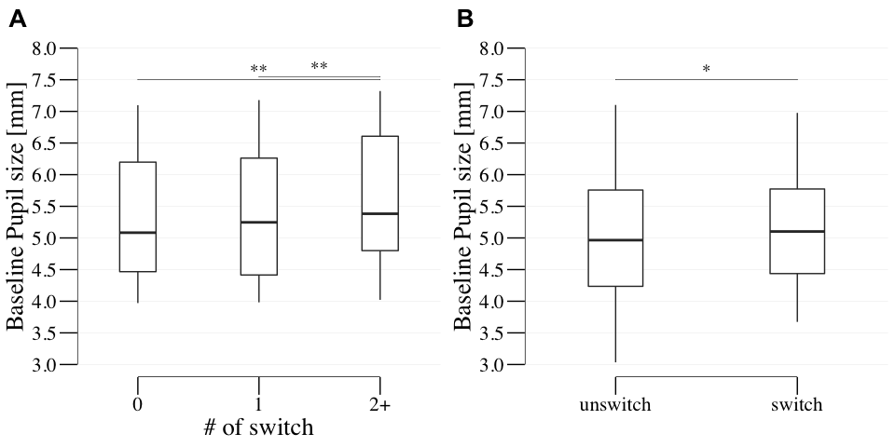

## quartz_off_screen   
## 2

We illustrated Figure 2A and 3A in the main manuscript using the baseline pupil size by mm from the raw-data. Other analysis methods were identical to the figures. **Supplemental Figure 1A** illustrates the grand-averaged baseline pupil changes across participants before the response cue onset, as a function of perceptual alternations number. The one-way repeated measures ANOVA revealed a significant main effect on the number of perceptual alternations ((1.65,34.68) = 9.79, = 0.001, = 0.318, = 79.632). The post-hoc multiple comparisons showed that the baseline pupil size in the >1-alt case was significantly larger than in the 0- and 1-alt cases ((1, 21) = 3.583, = 0.002, Cohen’s = 0.233, = 21.968; (1, 21) = 3.275, = 0.004, Cohen’s = 0.198, = 11.768, respectively), **Supplemental Figure 1B** shows the grand-averaged time-course of baseline pupil changes parameterized by alternation cases (yes or no). Consistent with Experiment 1, a paired t-test for averaged changes in baseline pupil size from -1000 ms to the response cue onset for each answer (i.e., the presence or absence of perceptual alternation) showed that the baseline pupil size in the presence of a perceptual alternation was significantly larger than in the absence of perceptual alternation ((1, 19) = -2.195, = 0.041, Cohen’s = 0.087, = 1.631).

## Transient Pupil Dilation/Constriction (PD/PC)

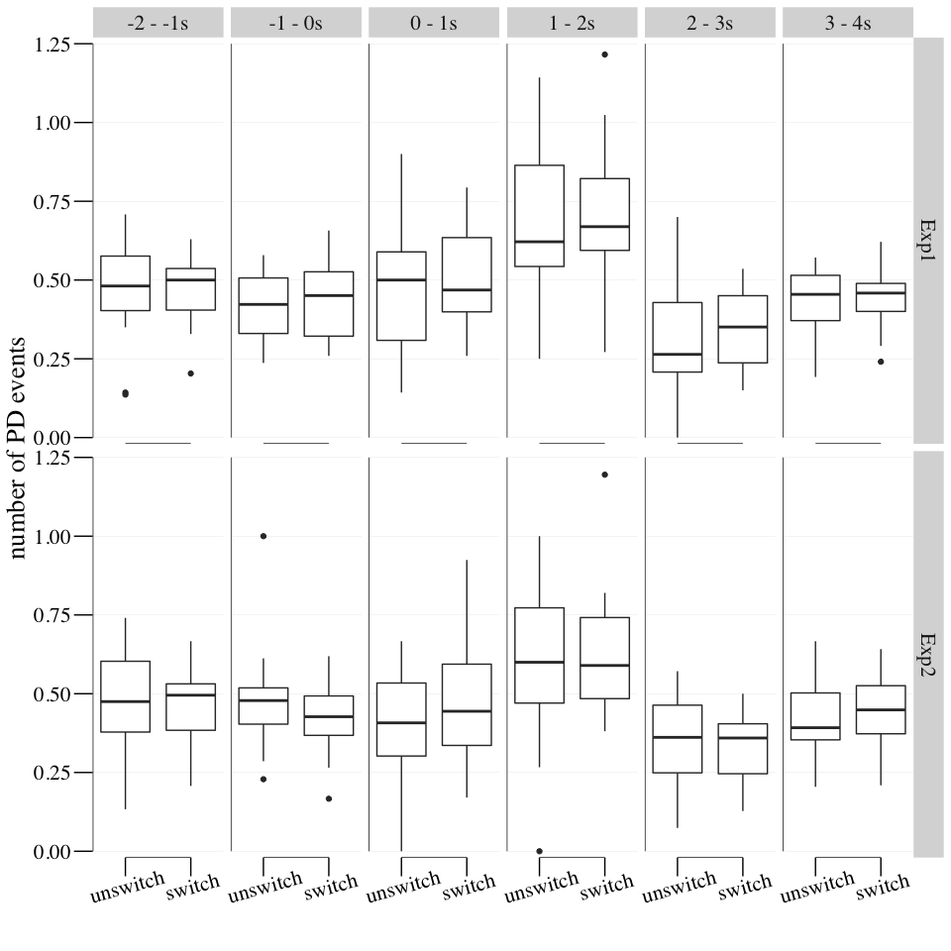

## quartz_off_screen   
## 2

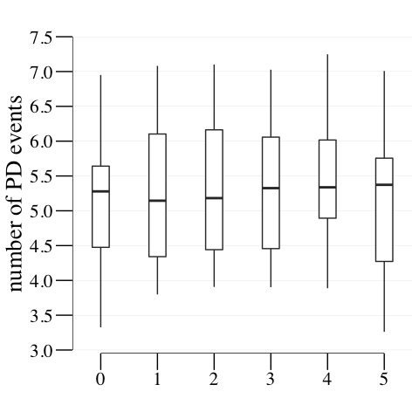

## quartz_off_screen   
## 2

To address the concern the baseline pupil size might be affected by the PD events, we additionally analyzed the number of PD events in the baseline pupil size analysis in every 1s window **(Supplemental Fig. 2A)**. Three-way anova (alternation x time window x experiment) only revealed a significant main effect of time window ((2.52,47.88) = 14.625, = 0, = 0.435). This could be explained by motor responses such as button-press responses **(Einhäuser et al., 2010; Grenzebach et al., 2021; Hupé et al., 2009)**. However, other main factors and interactions were not significant (p > 0.05).

We further calculated the correlation between the baseline pupil size and the number of transient PD events as shown in **Supplemental Fig.3**. The number of PD events during the early 4-s part of the observation period before the window of baseline pupil size. The data were fitted by a simple regression model ( = 0.03 + 5.178, = 0.048, = 0.5202, = 0.6039), indicating that there was no evidence that increasing number of PD events can explain the baseline pupil size in the current study.